HW1
- Submission date: 07/11/2025 (11:59 PM)
- Revise the in the Class 1 and Class 2 slide decks thoroughly before attempting the assignment.
- Please submit well commented code.
- Submitting a PDF explaining your code is highly encouraged.

- Cumulative Distribution Functions. For a given data distribution 𝑓(𝑥), the cumulative distribution function 𝐹(𝑥) is the probability that the data takes values in the interval (−∞, 𝑥], i.e.,
𝐹(𝑥) = 𝑃[𝑋 ≤ 𝑥]
  - Given that 𝑋 ∼ 𝒩(𝜇, 𝜎²), using appropriate R commands, find
    - 𝐹(−3.5) when 𝜇 = 1.0, 𝜎 = 2
      - 0.01222447
    - 𝐹(0.5) when 𝜇 = −5.0, 𝜎 = 4
      - 0.9154343
  - Given that 𝑋 ∼ 𝜒², using appropriate R commands, find
𝑘
    - 𝐹(2.5) when 𝑘 = 15.
      - 0.0001272254
    - 𝐹(15) when 𝑘 = 35.
      - 0.001252032
  - Explain the relation (if any) between the CDF and tail probability
The tail probability is equal to 1 – CDF. The R command for this is pnorm(Z-score, other parameters such as mean and standard deviation) which stands for probability of normal distribution. It provides CDF. The command for chi squared in part b is pchis(Z score, other parameters such as degrees of freedom).

- Tail Probabilities. For this question, please read Sec. 6.2, 6.3 and 6.4 in “Probability” by Seymour Lipschutz, 3rd edition. As mentioned in class, the eBook is available on the BU Library website.
  - Solve problem 6.51.
  - Find P(k) for the binomial distribution B(n, p) where:
  - (a) n = 5, p = 1/3, k = 2 -> 0.3292181
  - (b) n = 7, p = 1/2, k = 3; -> 0.2734375
  - (c) n = 4, p = 1/4, k = 2. -> 0.2109375
  - The formula is given in the textbook. It is combination(succesTrials,,Trials) * (prob of success)^successTrials * (prob of failure or 1 – success)^failedTrials or 1- success. The combination formula is given as shown:
succesTrials!/NumTrials!(successTrials-NumTrials)!
  - Solve problem 6.67,
  - Let Z be the standard normal random variable. Find
  - (a) P(–0.81 ≤ Z ≤ 1.13) -> 0.6617918
  - (b) P(–0.23 ≤ Z ≤ 1.6) -> 0.5361548
  - (c) P(0.53 ≤ Z ≤ 2.03) -> 0.2768777
  - (d) P(0.15 ≤ Z ≤ 1.50) -> 0.3735751
  - To solve this we use the textbook and use the rules where if the range is between a negative and positive, we add the absolute value of both z values. If both of them are positive, we subtract the larger z value from the lesser one and if both are negative we do the absolute value and do the same thing.
  - Solve problem 6.68,
  - Let Z be the standard normal random variable. Find
  - (a) P(Z ≤ 0.73) -> 0.7673049
  - (b) P(Z ≤ 1.8) -> 0.9640697
  - (c) P(Z ≥ 0.2) -> 0.4207403
  - (d) P(Z ≥ –1.5) -> 0.9331928
  - (e) P(Z = 1.8) -> 0
  - (f) P(|Z| ≤ 0.25) -> 0.1974127
  - For this we just do 1 – p for z values that are in the greater than. Probability of an exact point is zero and probability of an absolute value is probability of a positive in that value minus the negative in that value.
  - Solve problem 6.70
  - Let X be normally distributed with mean μ = 8 and standard deviation σ = 4. Find:
  - (a) P(5 ≤ X ≤ 10) -> 0.4648351
  - (b) P(10 ≤ X ≤ 15) -> 0.2684784
  - (c) P(3 ≤ X ≤ 9) -> 0.4930566
  - (d) P(3 ≤ X ≤ 7) -> 0.2956439
  - (e) P(X ≥ 15) -> 0.04005916
  - (f) P(X ≤ 5) -> 0.2266274
  - To do this we use the pnorm functions and change the parameters to have a mean of 8 and sd of 4. After that we subtract to find the probabilities in between and for less than we do 1-pnorm(num)
  - Solve problem 6.71.
  - Suppose the weights of 2000 male students are normally distributed with mean μ = 155 lb and standard deviation σ = 20 lb. Find the number of students with weights:
  - (a) not more than 100 lb, -> 5.959526 or round down to 5
  - (b) between 120 and 130 lb (inclusive), -> 131.1812 or round down to 131
  - (c) between 150 and 175 lb (inclusive) -> 880.1021 or round down to 880
  - (d) greater than or equal to 200 lb -> 24.44895 or round down to 24
  - To do this we use the pnorm function with the given parameters and since we have the set number we multiply it by 2000 to find how many students fit the criteria. We round down since there cant be partial people/

- More tail probability. You may use either the tail probability tables or R commands to solve these problems. A quality control engineer collects 4 IID measurements 𝑋₁, ⋯ , 𝑋₄ ∼ 𝒩(𝜇, 4). What is the
probability of observing a deviation, i.e., ∑⁴ (𝑋𝑖 − 𝜇)², at least as large as 35.0 if 𝜇 is 10.0?
𝑖=1
Since we are doing squared deviations from the True mean as given from the formula, we are finding the tail of a chi squared statistic divided by the variance. Thus in the r code we have 35/4 as the chisquared statistic function and finding the tail end as it is at least as large as 35. The answer is 0.06766126 or 68 percent.

- Sample mean and variance. This problem explores two concepts discussed in class (i) sample mean ( 𝑋̅) and sample variance (𝑠²) themselves have distributions, i.e., they are not constants, and (ii) as one averages over more data, both these estimators converge to their true/population counterparts.
  - Fix a sample size 𝑛. In R, generate 𝑘 groups of Gaussian random numbers (𝒩(𝜇, 𝜎²)), with each group containing 𝑛 samples. Let 𝑋̅(𝑖), 1 ≤ 𝑖 ≤ 𝑘, be the sample mean for the 𝑖^{𝑡ℎ} group. Plot the histogram of the sample means, and show that, for large enough values of 𝑘, the histogram
approximates 𝒩 (𝜇, 𝜎2). You may use KDE plots instead of a histogram.
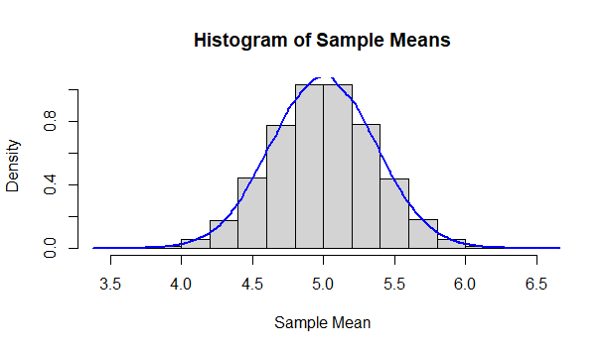
𝑛
  - Now, fix 𝑘 = 1. For very large values of 𝑛, plot a sequence of sample means converging to 𝜇.
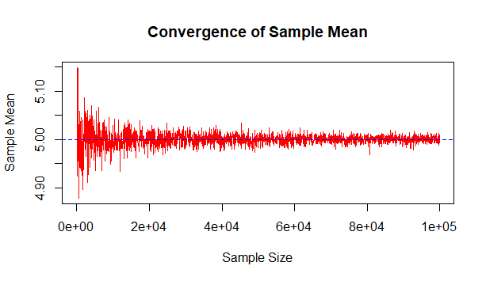
Fixing k=1 in part (b) allows us to observe how the sample mean from a single group becomes more accurate and converges to the true population mean as the sample size n increases, illustrating the Law of Large Numbers. Unlike part (a), which shows the distribution of many sample means (Central Limit Theorem), part (b) focuses on how a single sample stabilizes and becomes less variable with more data.

- The Central Limit Theorem. In this problem, you will empirically investigate the Central Limit Theorem (CLT) in R by simulating repeated sampling from a non-normal population distribution and analyzing the distribution of sample means.
  - Generate a large population of random numbers from a right-skewed distribution, e.g., the exponential distribution with rate parameter λ = 1.
We use the r function rexp() and set the rate parameter equal to 1 to create the exponential curve.
  - Plot the histogram and density curve of the population distribution.
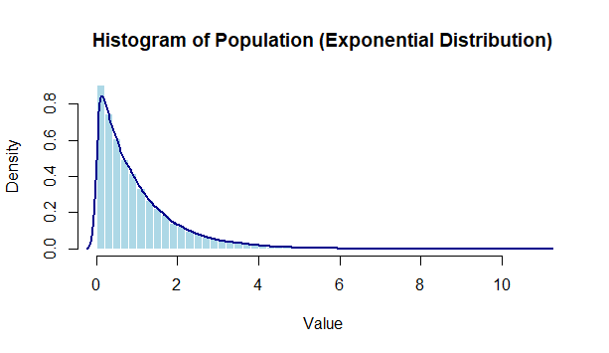
We use hist() to plot the curve.
  - Compute and report the population mean and variance. Hint: for parts a-c, you might want to find how the following functions work: rexp(), hist(), density(), mean(), var(). This will involve
some searching on the internet. Most standard distributions have their means and variances listed online (on Wikipedia, for example).
Population Mean: 0.997462
Population Variance: 0.9899683
As we can see both converge to ~1
  - Decide on several sample sizes, e.g., n = 5, 30, 100. For each sample size: (i) Perform repeated sampling (e.g., 10,000 times), (ii) For each sample, compute the sample mean, 𝑋̅, and store the results. Hint: What do the following functions do replicate(), sample()?
Replicate(n,function()) reproduces the function n amount of times and stores the results as a vector, matrix or list. Sample(n,list) gets 4 random items in the list with replacement. To do this task we call replicate on the outside with the mean of the single iteration of samples in the middle for a given amount of times(I chose 10,000).
  - Let’s denote the population mean and variance of the chosen distribution by 𝜇 and 𝜎² respectively.
As discussed in class, for each sample size (i) plot the histogram of ^{𝑋}̅−𝜇 , and (ii) overlay a standard
(𝜎/√𝑛)
normal density curve. Comment on how the shape of the distribution changes as the sample size increases. You might see something interesting beyond 𝑛 = 30.
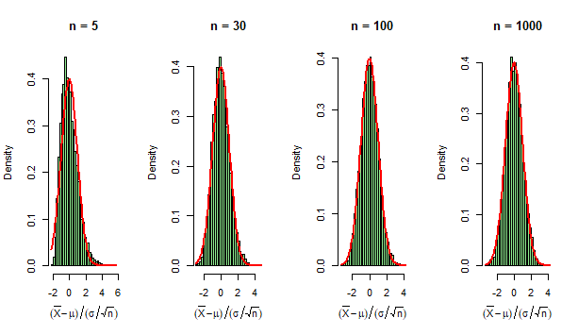As we can see it starts off as right skewed but with more iterations it follows a normal distribution curve.

After 1000 iterations we can see a

